# Department of Computing

**CS 212: Object Oriented Programming**

**Class: BESE-11AB**

**Lab04: Flow Control [Loops, Decisions & Arrays]**

**Date: 31st March, 2021 Time: 2:00pm- 4:50pm, 09:00am-11:50 am**

**Instructor: Ms. Hania Aslam**

## Learning Objectives

So far in the previous labs you have learnt to write programs that involve conditionals and iterations. Towards the very beginning of the semester we have looked at variables and how they store values that are required later in the program for calculations. This week’s lab focuses on a special variable that lets us store and access several values under the same name. These type of special variables, that allow us to store data items in contiguous memory locations, are called arrays. In today’s lab you learn the basics about array manipulation.

## Task #1:

Write a Java program that reads 10 numbers from the end user into an array, and only prints out the odd numbers in reverse order.

**Code:**

package com.company;  
import java.util.Scanner;  
  
public class Task01 {  
  
 public static void main(String[] args) {  
  
 //Declaring and initializing array  
 int [] num_array = new int[10];  
  
 Scanner sc = new Scanner(System.*in*);  
  
 //For loop for taking all the inputs  
 for (int i = 0; i < 10; i++){  
  
 System.*out*.printf("Enter Num %d: ",i+1);  
 num_array[i] = sc.nextInt();  
  
 }  
  
 //Condition for checking odd numbers and printing them in reverse order  
 for (int i = 9; i > -1; i--){  
  
 if (num_array[i] % 2 != 0){  
 System.*out*.println(num_array[i]);  
 }  
 }  
 }  
  
  
}

**Output Screenshot:**

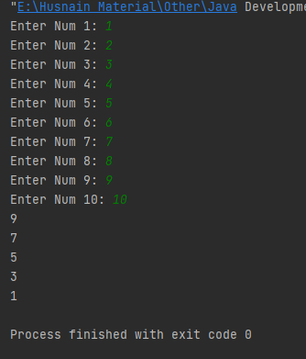

## Task #2:

Write a Java program that reads 10 numbers from the end user, but does not allow the user to enter duplicates. This means that if a number has been entered already, the program will not accept this input again, instead user shall be asked to enter a different number.

## Code:

package com.company;  
  
import java.util.Scanner;  
  
public class Task02 {  
  
 public static void main(String[] args) {  
  
 //Declaring and initializing array  
 int [] num_array = new int [10];  
 //Declaring 'num' variable  
 int num;  
  
 Scanner sc = new Scanner(System.*in*);  
  
 //For loop for taking all inputs  
 for (int i = 0; i < 10; i++){  
  
 System.*out*.printf("Enter Num %d: ", i+1);  
 num = sc.nextInt();  
  
 //Checking for duplicate numbers  
 for (int integer : num_array) {  
  
 if (num == integer) {  
 System.*out*.println("Invalid Entry!");  
 i--;  
 break;  
 }  
 }  
 //Storing value in array if it is not a duplicate number  
 num_array[i] = num;  
  
 }  
 }  
}

## Output Screenshot:

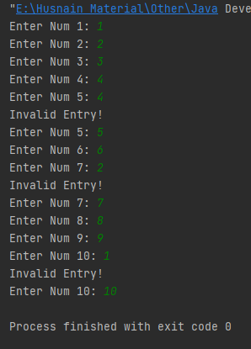

## Task #3:

Develop a Java application that can be used by a system administrator and an end user.

A system administrator can add user names and passwords for the authorized end users. Your program shall store and maintain the information entered by the system administrator in two separate arrays i.e userName[] and passwords[]. (Assume that each user name corresponds with the password value on the basis of index value i.e userName[0] = “Rayyan” and password[0] =“Rayyan@123%”).The system can have maximum ten end users.

In case the system is being used by an end user, then user shall be prompted to enter the user name and password. The user entered values shall be compared against the



values already stored in the arrays. In case of a successful login print a welcome

message to the console otherwise display incorrect login credentials message. In case of incorrect login attempt user shall be provided two more chances before program exits.

**Note:** Test your program by first entering values as an administrator and then as an end user who is tryingto log onto the system.

**Code:**

package com.company;  
  
import java.util.Scanner;  
  
public class Task03 {  
  
 public static void main(String[] args) {  
  
 //Declaring variables being used in the program  
 int identity;  
 int no_of_users;  
 String username;  
 String key;  
 int index_username = -1;  
 int index_password = -1;  
 String[] user_name = new String[10];  
 String[] password = new String[10];  
  
 //Creating an instance of the Scanner class  
 Scanner sc = new Scanner(System.*in*);  
  
 for (int j = 0; j < 2; j++) {  
  
 //Asking the user if he is a user or an administrator  
 System.*out*.print("Are you a user or administrator (0 for Administrator / 1 for User): ");  
 identity = sc.nextInt();  
  
 //This block of code runs if the person is an administrator  
 if (identity == 0) {  
  
 System.*out*.print("Number of users you want to register: ");  
 no_of_users = sc.nextInt();  
  
 //For loop for inputting all the data of the user into the system  
 for (int i = 0; i < no_of_users; i++) {  
  
 System.*out*.printf("Enter the username of User %d: ", i + 1);  
 user_name[i] = sc.next();  
  
 System.*out*.print("Enter the password: ");  
 password[i] = sc.next();  
  
 System.*out*.println();  
 }  
 System.*out*.println("Registration Successfully Done!\n");  
  
 //This block of code runs when the person is a user  
 } else if (identity == 1) {  
  
 System.*out*.println("Log-In Menu!");  
 System.*out*.println("------------ \n");  
  
 for (int i = 1; i <= 3; i++) {  
  
 //Taking input the username of the user  
 System.*out*.print("Username: ");  
 username = sc.next();  
  
 //Checking if the user is registered on the system  
 for (String name : user_name) {  
  
 if (username.equals(name)) {  
  
 //Getting the index of username  
 for (int p = 0; p < user_name.length; p++){  
  
 if (user_name[p].equals(username)){  
  
 index_username = p;  
 break;  
 }  
 }  
  
 for (int k = 0; k < 3; k++) {  
  
 //Taking input the password of the user  
 System.*out*.print("Password: ");  
 key = sc.next();  
  
 //Getting index of the entered password  
 for (int p = 0; p < password.length; p++){  
  
 if (password[p].equals(key)){  
  
 index_password = p;  
 break;  
 }  
 }  
  
 //Checking if the entered credentials of the user match with that of the system  
 for (String word : password) {  
  
 if (key.equals(word) && index_username == index_password) {  
  
 //Printing welcome message if the credentials match  
 System.*out*.println("ACCESS GRANTED! Welcome.");  
 System.*exit*(0);  
 }else{  
 //The user has limited number of tries  
 System.*out*.println("Wrong Password! You have " + (2-k) + " attempt(s) left.");  
 break;  
 }  
 }  
 }  
 //Printing warning message on entering wrong credentials. System will shut down after some wring attempts  
 System.*out*.println("Too Many Wrong Attempts. System is Shutting Down.");  
 System.*exit*(0);  
  
 }  
 }  
 System.*out*.printf("You are not registered into the system. You have %d attempt(s) left.\n", 3-i);  
 }  
 System.*out*.println("Too Many Wrong Attempts. System is Shutting Down.");  
 System.*exit*(0);  
 }  
  
 }  
 }  
 }

**Output Screenshot:**

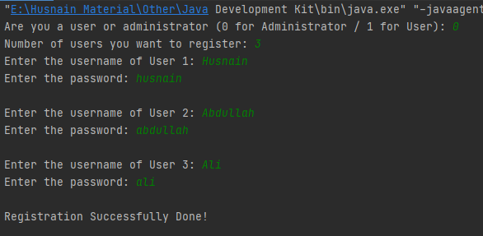

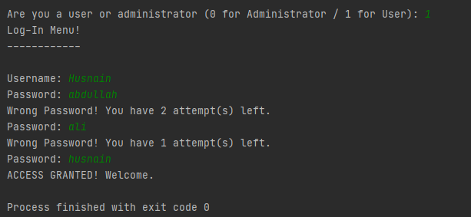

## Hand-in:

Please upload the source code of the lab tasks included in this manual at an appropriate location/slot on LMS.